**Candidate’s Declaration Form - India**

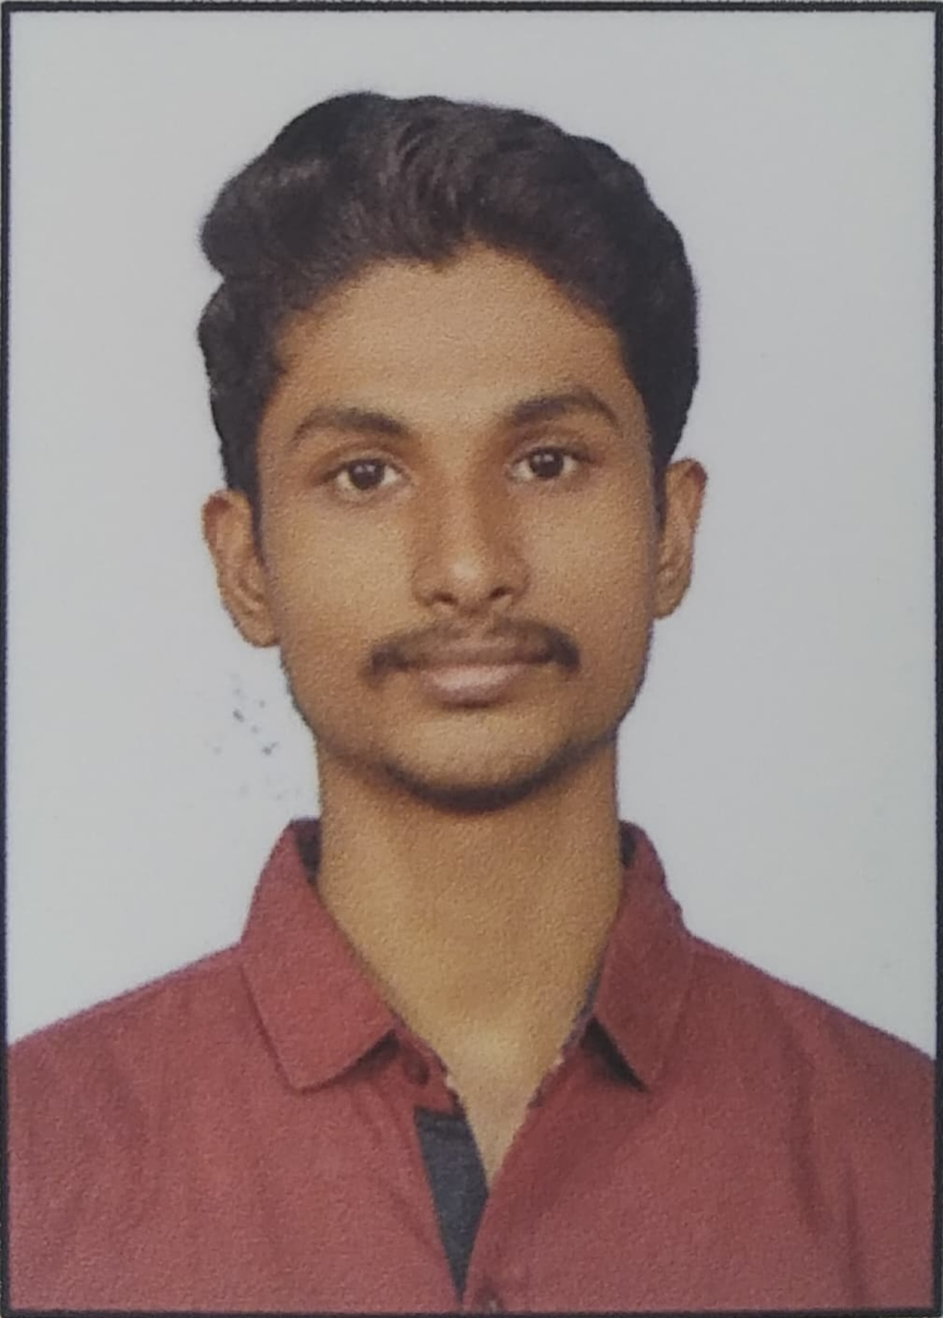

***Instructions***:

Please provide all the information requested in this form. Incomplete Candidate

Declaration Forms (CDFs) will be returned. **All** supporting documents **must** accompany this form. Photocopies must be **legible.** We have included a checklist to assist you to complete your application comprehensively**.**

**PERSONAL DETAILS**

FullName(First/Middle/Last): Rajkumar R

Father’s/ Mother’s Name: Ramesh G

Date ofBirth(DD/MM/YY): 22/07/1999 MobileNumber: 8489094282 Nationality: Indian

PassportNumber: V0654935 Dateofissue: 21/09/2021 Date ofexpiry: 20/09/2031

PAN Number / Social Security Number (If worked/studied in the US/Any otherCountry) DDSPR8764N

**Change of Name if Applicable**

FormerName/MaidenName Date ofNameChange

|  |  |
| --- | --- |
| **Current Address** | **PermanentAddress** |
| DoorNo./Street: 134, N 166 Munichalai Road,  City: Madurai  State: Tamil Nadu  Pin: 625009  Period ofStay: 25 Years  Landmark: Opposite to Masjid Noortheen Mosque  Landline:  Is your residence your own or a rentedplace? Own  If rented, please provide details of theLandlord  Name: ______________________________________________  Address: ______________________________________________  _______________________________________________________  City State: _________________  Pin: __________________________ | DoorNo./Street: 134, N 166 Munichalai Road,  City: Madurai  State: Tamil Nadu  Pin: 625009  Period ofStay: 25 Years  Landmark: Opposite to Masjid Noortheen Mosque  Landline:  Is your residence your own or a rentedplace? Own  If rented, please provide details of theLandlord  Name: ______________________________________________  Address: ______________________________________________  _______________________________________________________  City State: _________________  Pin: _____________________________ |

**Note - Please attach 1 address proof each for your current & permanent address.**

**EMPLOYMENT DETAILS – Last 03 Companies**

|  |  |  |  |  |
| --- | --- | --- | --- | --- |
| **(EMP-1) Current Employment 1** | | | | |
| **PERMANENT / CONTRACT EMPLOYMENT** | | | | |
| Name of Company | Jio Platforms Limited | | | |
| Where were you employed? | ✓RegisteredCorporate Office | | * BranchOffice | |
| Company Address  (Where you were employed) | Door No./Street Reliance Corporate Park, Thane Belapur Road, Ghansoli, | | | |
| City | Navi Mumbai | State | Maharashtra |
| Pin | 400701 | Phone |  |
| Period of employment from / to (DD/MM/YYYY) | 20.06.2022 | | Employee Code | 55052432 |
| Designation | Software Development Engineer I | | Remuneration |  |
| Nature of Employment (Permanent / Contract) | Permanent | | If Contract, please provide company name |  |
| Supervisor’s Name and Designation | Eswara Reddy Manager | | (Email ID) Supervisor / HR | Eswara.reddy@ril.com |
| **State your reason for leaving** | For Career Growth | | | |
|  | | | |

# **Note: Please attach legible photocopies of the following documents relevant to the entries above**

1)AppointmentLetter 2) Service Letter / Resignation Acceptance

|  |  |  |  |  |
| --- | --- | --- | --- | --- |
| **(EMP-2) Previous EMP** | | | | |
| **PERMANENT / CONTRACT EMPLOYMENT** | | | | |
| Name of Company | Insessor Technology Private Limited | | | |
| Where were you employed? | ✓RegisteredCorporate Office | | * BranchOffice | |
| Company Address  (Where you were employed ) | Door No./Street Meera Nagar, RHB Colony, Bhuwana | | | |
| City | Udaipur | State | Rajasthan |
| Pin | 313001 | Phone |  |
| Period of employment from / to (DD/MM/YYYY) | 13.09.2021 to 25.03.2022 | | Employee Code | 049 |
| Designation | Software Engineer Trainee | | Remuneration |  |
| Nature of Employment (Permanent / Contract) | Permanent | | If Contract Please  provide company name |  |
| Supervisor’s Name and Designation | Indra Kumar Prajapat, Solution Architech | | (Email Id) Supervisor / HR | Indra@insessor.com |
| **State your reason for leaving** | Technology Switching | | | |
|  | | | |

# **Note: Please attach legible photocopies of the following documents relevant to the entries above**

1. Relieving / Service letter

|  |  |  |  |  |
| --- | --- | --- | --- | --- |
| **(EMP-3) Previous EMP** | | | | |
| **PERMANENT / CONTRACT EMPLOYMENT** | | | | |
| Name of Company |  | | | |
| Where were you employed? | * RegisteredCorporate Office | | * BranchOffice | |
| Company Address  (Where you were employed ) | Door No./Street | | | |
| City |  | State |  |
| Pin |  | Phone |  |
| Period of employment from / to (DD/MM/YYYY) |  | | Employee Code |  |
| Designation |  | | Remuneration |  |
| Nature of Employment (Permanent / Contract) |  | | If Contract, Please provide company name |  |
| Supervisor’s Name and Designation |  | | (Email ID) Supervisor / HR |  |
| **State your reason for leaving** |  | | | |
|  | | | |

# **Note: Please attach legible photocopies of the following documents relevant to the entries above**

1) Relieving / Service letter

|  |  |  |  |  |
| --- | --- | --- | --- | --- |
| **(EMP-4) Previous EMP** | | | | |
| **PERMANENT / CONTRACT EMPLOYMENT** | | | | |
| Name of Company |  | | | |
| Where were you employed? | * RegisteredCorporate Office | | * BranchOffice | |
| Company Address  (Where you were employed ) | Door No./Street | | | |
| City |  | State |  |
| Pin |  | Phone |  |
| Period of employment from / to (DD/MM/YYYY) |  | | Employee Code |  |
| Designation |  | | Remuneration |  |
| Nature of Employment (Permanent / Contract) |  | | If Contract, Please provide company name |  |
| Supervisor’s Name and Designation |  | | (Email ID) Supervisor / HR |  |
| **State your reason for leaving** |  | | | |
|  | | | |

# **Note: Please attach legible photocopies of the following documents relevant to the entries above**

1. Relieving / Service letter

|  |  |  |  |  |
| --- | --- | --- | --- | --- |
| **(EMP-5) Previous EMP** | | | | |
| **PERMANENT / CONTRACT EMPLOYMENT** | | | | |
| Name of Company |  | | | |
| Where were you employed? | * RegisteredCorporate Office | | * BranchOffice | |
| Company Address  (Where you were employed ) | Door No./Street | | | |
| City |  | State |  |
| Pin |  | Phone |  |
| Period of employment from / to (DD/MM/YYYY) |  | | Employee Code |  |
| Designation |  | | Remuneration |  |
| Nature of Employment (Permanent / Contract) |  | | If Contract, Please provide company name |  |
| Supervisor’s Name and Designation |  | | (Email ID) Supervisor / HR |  |
| **State your reason for leaving** |  | | | |
|  | | | |

# **Note: Please attach legible photocopies of the following documents relevant to the entries above**

1) Relieving / Service letter

Authorization/ Declaration and Undertaking

If employed with NTTDATA Business Solutions, I agree to provide copies of all relevant certificates. I understand that employment with NTTDATA Business Solutions isgovernedbytheiremploymentpoliciesasapplicable,includingsatisfactoryinformationfrombackgroundchecks.

I hereby certify that all information provided herein, is true and complete to the best of my knowledge and belief. I provide my consent to authorize NTTDATA Business Solutions and its representative to authenticate information I have provided in my resume and this Candidate Declaration Form (CDF). To conduct enquiries as may be necessary at the company’s discretion, I authorize all who may have information relevant to this enquiry to disclose it to NTTDATA Business Solutions and/or its representative. I release all concerned fromany liability on account of suchdisclosures.

I also declare that the information provided by me in my resume and application for employment to NTTDATA Business Solutions and its representative is authentic, and I am liable for inaccuracies and omissions if any.

I hereby promise to extend total co-operation and provide relevant documents required.

Rajkumar R

Full Name ofthe Candidate:Signature of theCandidate: